|  |  |
| --- | --- |
| Name: | Class: |



**➀ Listen and write the numbers.** Score / 5

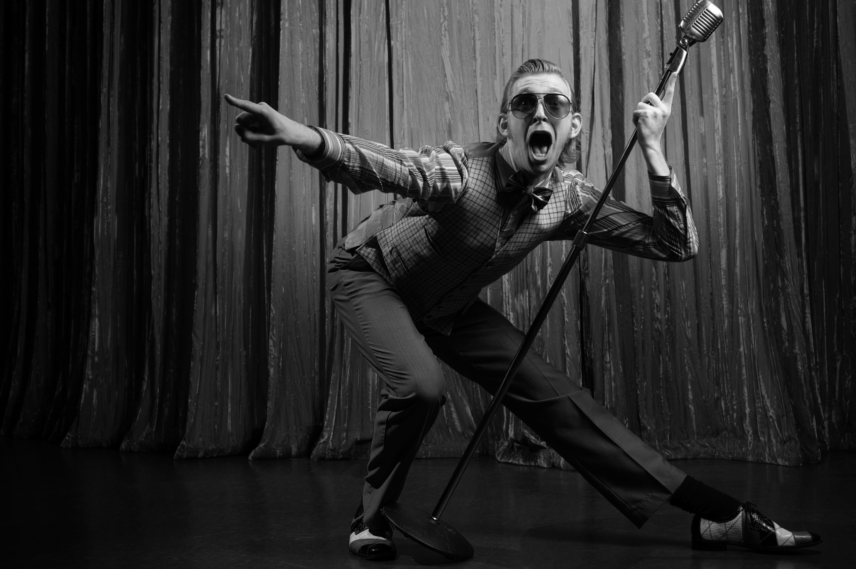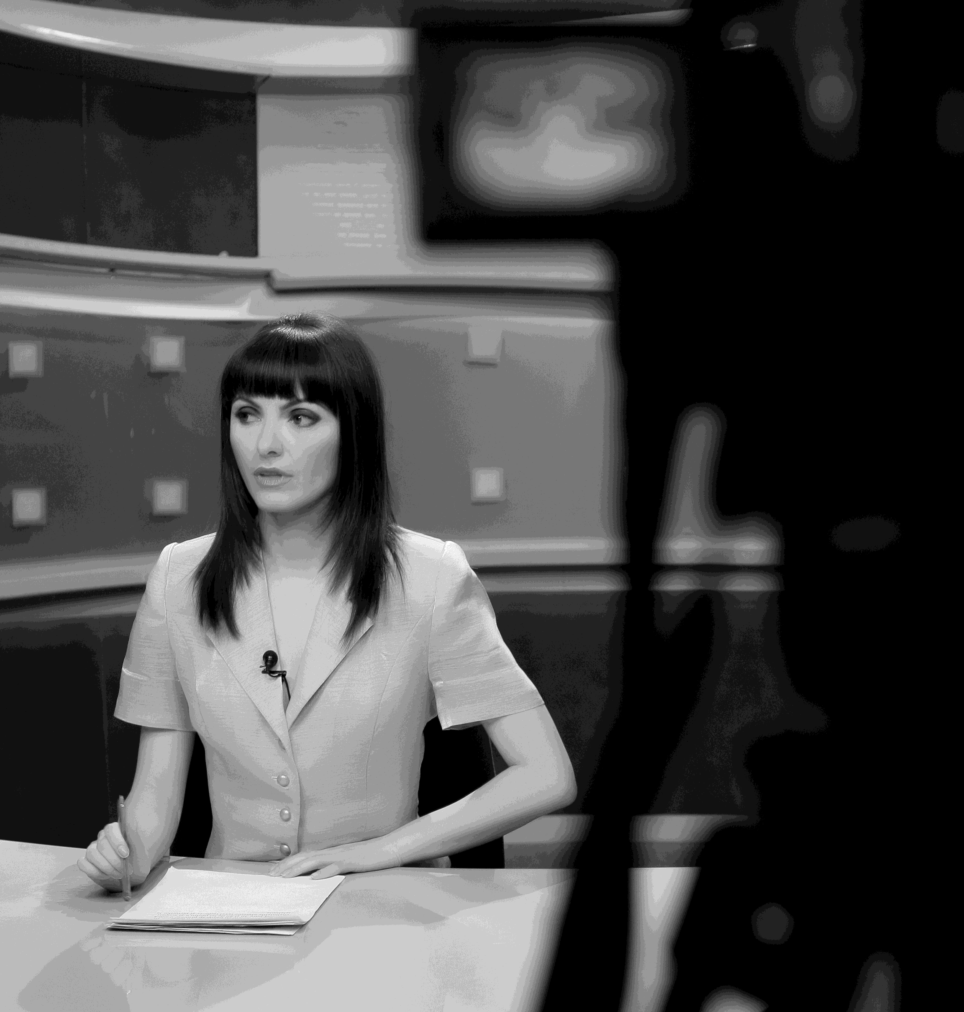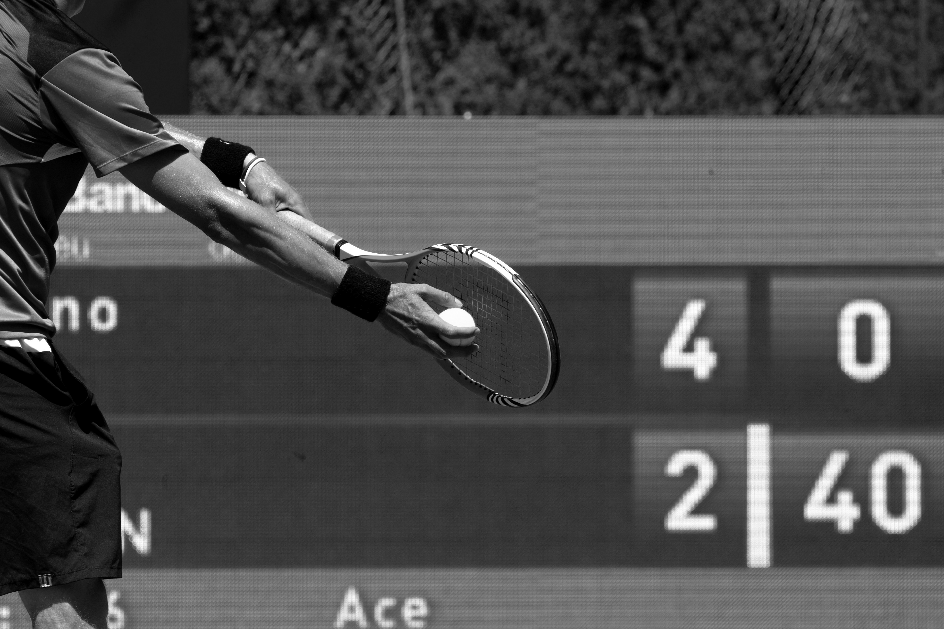

1 __ __

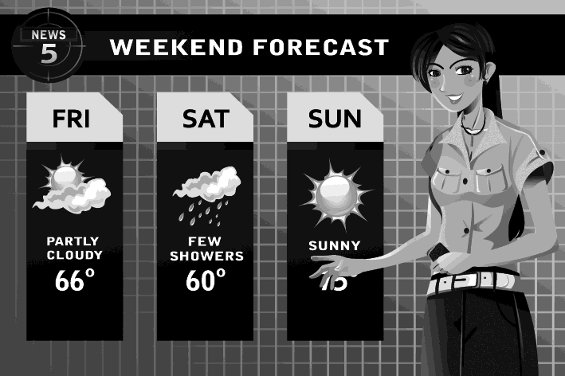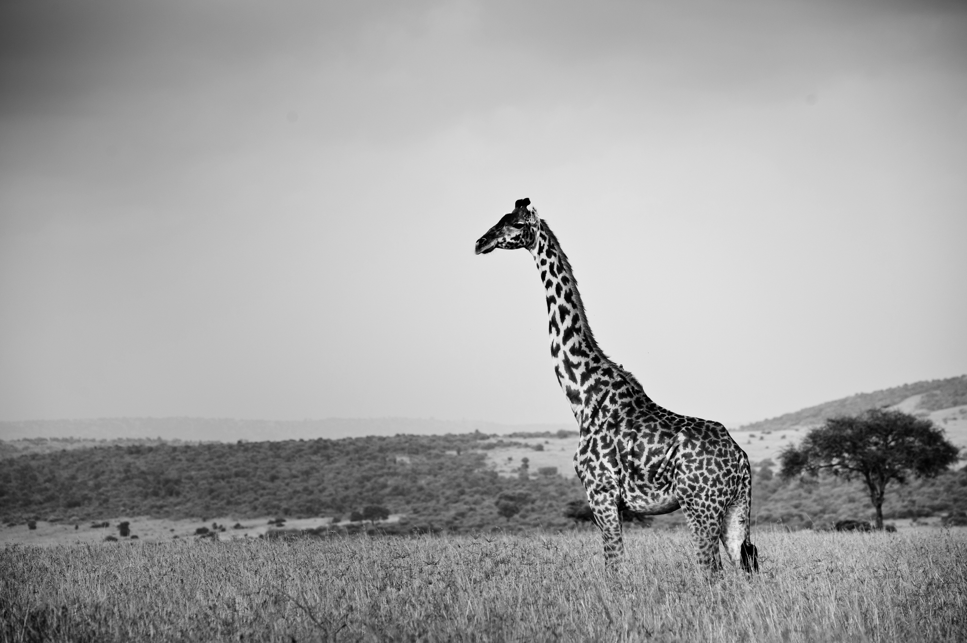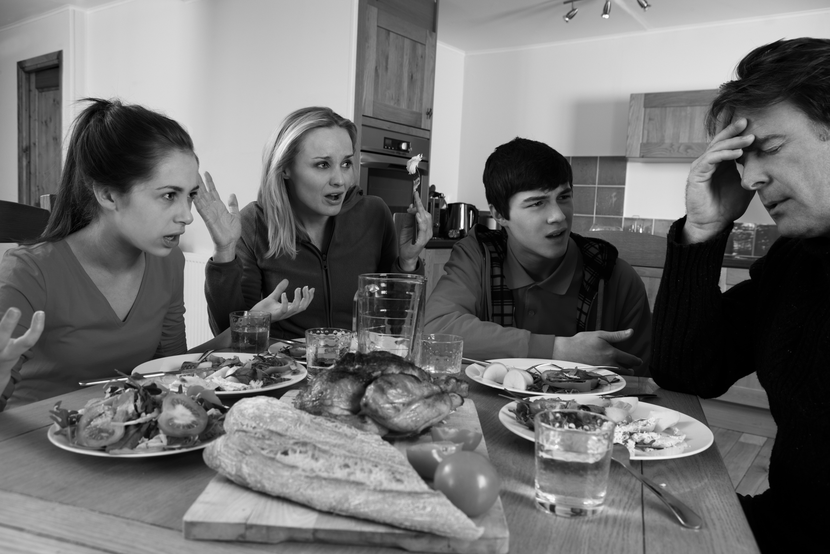

__ __ __

**➁Read and correct the sentences.**  Score / 10

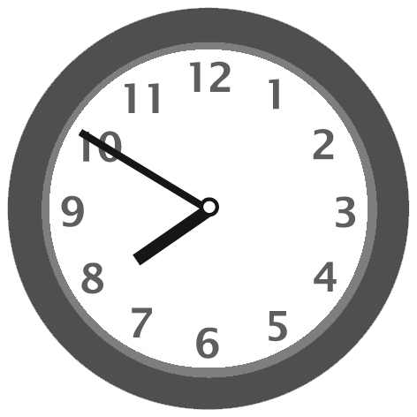➊ Shari got up at ~~seven thirty.~~

Shari got up at ten to eight.

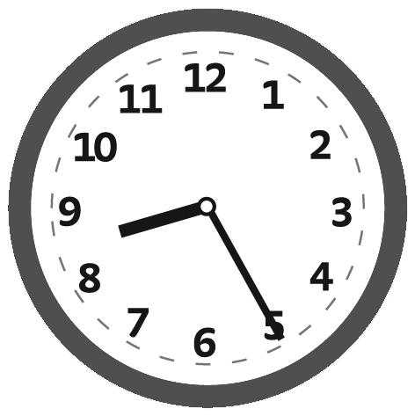➋ She had breakfast at eight o’clock.

_____________________________________________

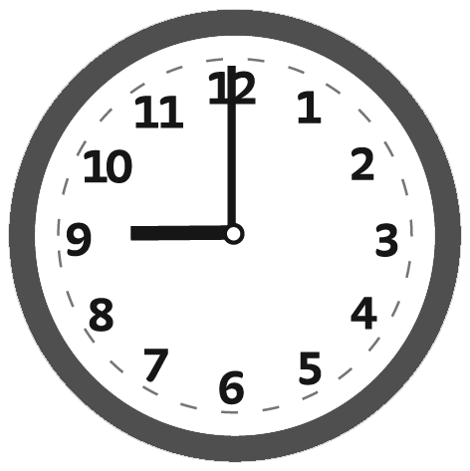

➌ She caught the bus at five to nine.

_____________________________________________

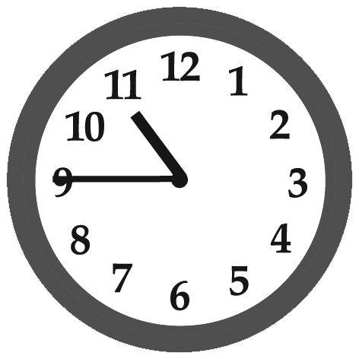

➍ She went to the supermarket at ten after eleven.

_____________________________________________

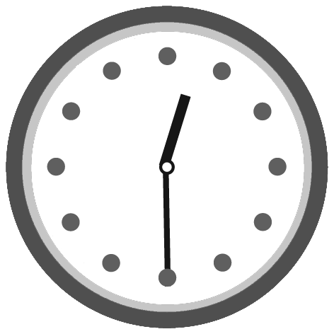

➎ She drank some orange juice at twenty to twelve.

_____________________________________________

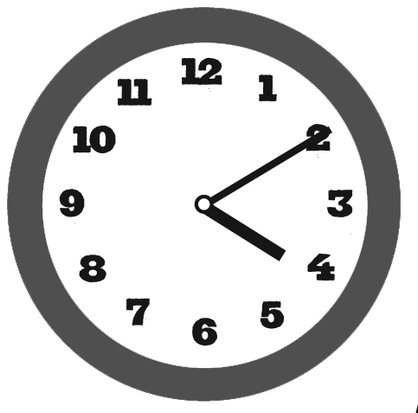

➏ She watched a comedy at ten to five.

_____________________________________________

Total unit score / 15